CUSTOMER SEGMENTATION

-using K-means clustering

REPORT

Submitted by

Naman Kumar Singh

(Team - 6)

CONTENT

| S.NO | TOPIC NAME | PG.NO |
| --- | --- | --- |
| 1. | Introduction | 3-4 |
| 2. | Literature Survey | 5-9 |
| 3. | Flowchart | 10 |
| 4. | Software and Hardware Requirements | 11 |
| 5. | Result | 12-13 |
| 6. | Conclusion | 14 |
| 7. | FutureScope | 15 |

CHAPTER-1

INTRODUCTION

OVERVIEW:

Customer segmentation using the K-means algorithm is a popular method in data analysis and marketing to categorize customers into distinct groups based on their behaviors and characteristics. Here's an overview of the process:

1**. Understanding K-means Algorithm**

K-means is an unsupervised machine learning algorithm that partitions data into K distinct clusters based on feature similarity. The primary steps of the K-means algorithm are:

**Initialization**: Select K initial centroids randomly.

**Assignment**: Assign each data point to the nearest centroid.

**Update**: Calculate the new centroids by taking the average of the points in each cluster.

**Iterate**: Repeat the assignment and update steps until convergence (when the centroids no longer change significantly).

2**. Steps in Customer Segmentation**

**Data Collection**

Collect data related to customer behaviors and characteristics. This data could include demographics, purchasing history, website interactions, etc.

**Feature Selection**

Select the relevant features that will be used for segmentation. Common features include:

- Age

- Gender

- Income

- Purchase frequency

- Average transaction value

- Customer tenure

- Product preferences

**Data Preprocessing**

Preprocess the data to make it suitable for the K-means algorithm:

Normalization/Standardization: Scale the features so that they have a mean of zero and a standard deviation of one.

**Handling Missing Values**: Fill or remove missing values.

Choosing the Number of Clusters (K)

Determine the optimal number of clusters using methods such as:

Elbow Method: Plot the sum of squared distances from each point to its assigned centroid for different values of K and look for an "elbow" point where the rate of decrease sharply changes.

**Silhouette Score**: Measures how similar a point is to its own cluster compared to other clusters.

Running K-means Algorithm

Run the K-means algorithm with the chosen K value:

- Initialize the centroids.

- Assign data points to the nearest centroid.

- Update centroids based on the mean of the assigned points.

- Iterate until convergence.

Evaluating the Results

**Evaluate the quality of the clusters**:

Inertia: Measures how tightly the clusters are packed.

**Silhouette Score**: Indicates how well each data point lies within its cluster.

Interpreting the Clusters

Interpret and label the clusters based on the characteristics of the data points within each cluster. For example, clusters might represent:

- High-value customers

- Discount shoppers

- Occasional buyers

- Loyal customers

**Implementing the Segmentation**

Use the customer segments to tailor marketing strategies, product recommendations, and customer service approaches. This can lead to more targeted marketing campaigns, improved customer satisfaction, and increased sales.

**3. Applications of Customer Segmentation**

Targeted Marketing: Create personalized marketing campaigns for different customer segments.

Product Development: Develop products that cater to the needs of specific segments.

Customer Retention: Identify at-risk customers and implement retention strategies.

Cross-selling and Up-selling: Recommend products that are likely to be of interest to specific segments.

CHAPTER-2

LITERATURE SURVEY:

Existing Problem:

While customer segmentation using K-means and other techniques can provide valuable insights and drive business decisions, several challenges and problems can arise:

1. Choosing the Right Number of Clusters (K)

Determining the optimal number of clusters is crucial but can be challenging. Methods like the Elbow Method or Silhouette Score provide guidance but are not always definitive, leading to potential under-segmentation or over-segmentation.

2. Data Quality Issues

Incomplete Data: Missing values can skew the clustering results.

Noisy Data: Outliers and irrelevant features can distort the clusters.

Inconsistent Data: Different data sources might have inconsistencies that need to be resolved before segmentation.

3. Feature Selection

Selecting the right features is critical. Irrelevant or redundant features can lead to poor clustering results. Identifying the most impactful features requires domain knowledge and sometimes trial and error.

4. Scalability

As the size of the customer dataset grows, running K-means can become computationally expensive. Large datasets might require more sophisticated approaches or dimensionality reduction techniques before applying K-means.

5. Cluster Interpretability

Interpreting the clusters meaningfully can be difficult. While the algorithm provides clusters, understanding what these clusters represent in real-world terms requires deep domain knowledge.

6. Dynamic Nature of Customer Behavior

Customer preferences and behaviors can change over time. Static segmentation might not capture these changes, leading to outdated insights. Continuous or periodic re-clustering might be necessary to stay updated.

7. Homogeneity Within Clusters

Clusters might not always be homogeneous. Even within a single cluster, significant variability can exist, making it challenging to tailor strategies effectively.

8. Business Relevance

The resulting clusters must align with business goals and strategies. Clusters that are statistically sound but lack practical relevance might not provide actionable insights.

9. Bias in Data

Biases in the data can lead to biased clusters. For instance, if historical data reflects certain biases (e.g., socio-economic, geographic), the resulting segments might perpetuate these biases.

10. Implementation Challenges

- Integration with Business Processes: Integrating segmentation results into existing business processes and systems can be challenging.

- Cross-functional Alignment: Different departments (marketing, sales, product development) must align on how to use the segmentation insights.

**Strategies to Address These Problems**

1. **Advanced Clustering Techniques**

- Use more advanced clustering techniques like hierarchical clustering, DBSCAN, or Gaussian Mixture Models (GMM) when K-means is insufficient.

- Consider ensemble methods that combine multiple clustering algorithms.

**2. Data Preprocessing and Cleaning**

- Invest in robust data cleaning and preprocessing pipelines.

- Use techniques like PCA (Principal Component Analysis) for dimensionality reduction to handle noisy data.

**3. Automated Feature Selection**

- Use automated feature selection methods and algorithms to identify the most relevant features.

- Incorporate domain expertise to validate and refine the feature selection process.

**4. Scalability Solutions**

- Use scalable computing resources and algorithms optimized for large datasets.

- Implement distributed computing frameworks like Apache Spark for handling large-scale data.

**5. Continuous Monitoring and Updating**

- Implement continuous monitoring of customer behaviors and periodic re-clustering.

- Use real-time data integration where feasible to keep segments up-to-date.

**6. Domain Knowledge and Expertise**

- Involve domain experts in the interpretation and validation of clusters.

- Ensure that the clusters align with practical business objectives and strategies.

By addressing these challenges proactively, businesses can make the most out of customer segmentation and drive meaningful outcomes.

PROPOSED SOLUTION:

To address the challenges in customer segmentation using the K-means clustering algorithm, we can propose a comprehensive solution that involves several key steps, from data preprocessing to model evaluation and continuous improvement. Here's a detailed outline of the proposed solution:

**1. Data Collection and Preprocessing**

Data Collection

Gather data from various sources, including customer transactions, web interactions, social media, customer service logs, and demographic information.

Data Cleaning

- Handle missing values: Impute missing data using statistical methods or machine learning models.

- Remove duplicates and outliers: Use techniques like IQR (Interquartile Range) or Z-score to identify and remove outliers.

- Normalize/Standardize data: Scale features to a standard range to ensure fair treatment by the algorithm.

Feature Selection and Engineering

- Select relevant features: Choose features that are likely to influence customer behavior (e.g., age, income, purchase frequency).

- Create new features: Engineer new features that might provide additional insights (e.g., recency, frequency, monetary value - RFM analysis).

- Dimensionality reduction: Use techniques like PCA (Principal Component Analysis) to reduce the feature space while retaining essential information.

**2. Choosing the Optimal Number of Clusters (K)**

Elbow Method

- Plot the within-cluster sum of squares (inertia) against the number of clusters.

- Identify the "elbow point" where the rate of decrease sharply changes.

Silhouette Score

- Calculate the silhouette score for different values of K.

- Choose the value of K with the highest average silhouette score.

**3. Running the K-means Algorithm**

Initialization

- Use methods like K-means++ to initialize centroids more effectively, reducing the chances of poor clustering.

Clustering

- Apply the K-means algorithm to partition the data into K clusters.

- Use iterative refinement to ensure convergence.

**4. Evaluating Clustering Quality**

Inertia

- Measure the sum of squared distances from each point to its assigned centroid.

Silhouette Score

- Evaluate how similar each point is to its own cluster compared to other clusters.

Cluster Validation

- Use additional validation techniques like Davies-Bouldin Index or Dunn Index to assess the cluster quality.

**5. Interpreting and Implementing Clusters**

Cluster Analysis

- Analyze the characteristics of each cluster to understand customer segments.

- Label clusters based on dominant features (e.g., high-value customers, budget-conscious shoppers).

Business Integration

- Develop targeted marketing strategies, personalized recommendations, and tailored customer service approaches based on the identified segments.

- Align clusters with business goals and ensure cross-functional alignment.

**6. Continuous Monitoring and Updating**

Real-time Data Integration

- Implement real-time data pipelines to continuously feed new data into the clustering model.

- Use streaming data processing frameworks like Apache Kafka and Apache Spark Streaming.

Periodic Re-clustering

- Periodically re-run the K-means algorithm to update clusters as customer behavior changes.

- Monitor cluster drift and adjust strategies accordingly.

**7. Advanced Techniques and Enhancements**

Use of Ensemble Methods

- Combine multiple clustering algorithms to improve robustness and accuracy.

Automated Feature Selection

- Implement machine learning techniques for automated feature selection and importance ranking.

Scalability Solutions

- Leverage distributed computing frameworks to handle large-scale data processing and clustering.

CHAPTER-3

FLOW CHART:

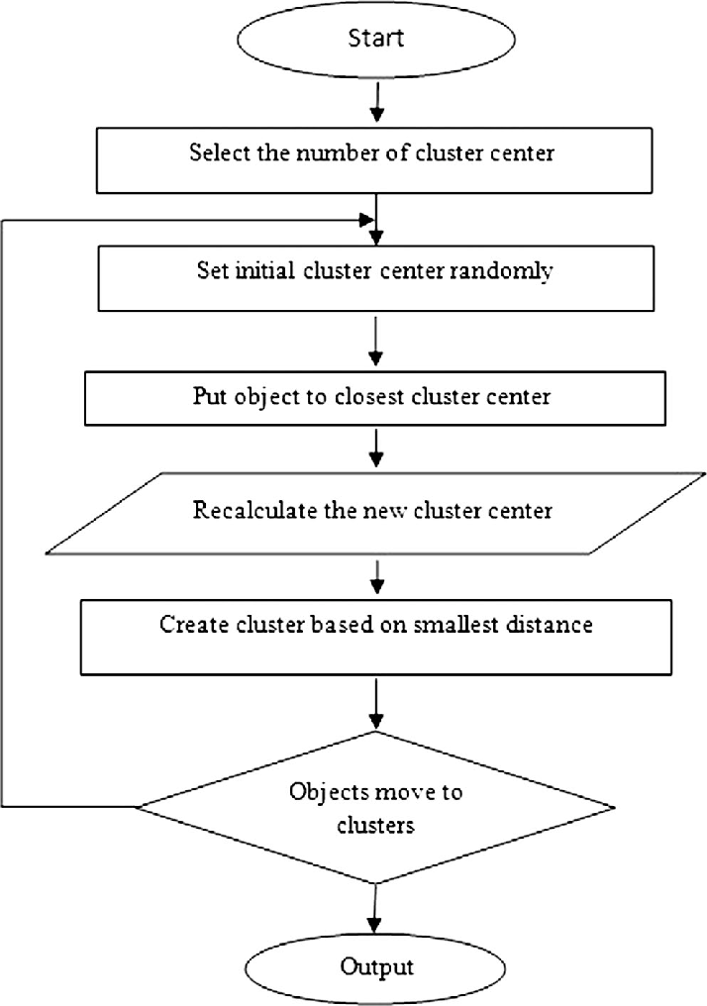

CHAPTER-4

SOFTWARE REQUIREMENTS:

To complete this project, you must required following softwares, concepts and packages

* python IDE
* python jupyter notebook
* packages:

-numpy

-matplotlib

HARDWARE REQUIREMENTS:

* For application development, the following Software Requirements are:
* Processor: Intel or high RAM: 1024 MB
* Space on disk: minimum 100 MB For running the application:
* Device: Any device that can access the internet Minimum space to execute: 20 MB
* The effectiveness of the proposal is evaluated by conducting experiments with a cluster formed by 3 nodes with identical settings, configured with an Intel CORE™ i7-4770 processor (3.40GHZ, 4 Cores, 8GB RAM, running Ubuntu 18.04 LTS with 64-bit Linux4.31.0 kernel)

CHAPTER-5

RESULT:

Input Dataset:

https://www.kaggle.com/datasets/vjchoudhary7/customer-segmentation-tutorial-in-python

Outputs:

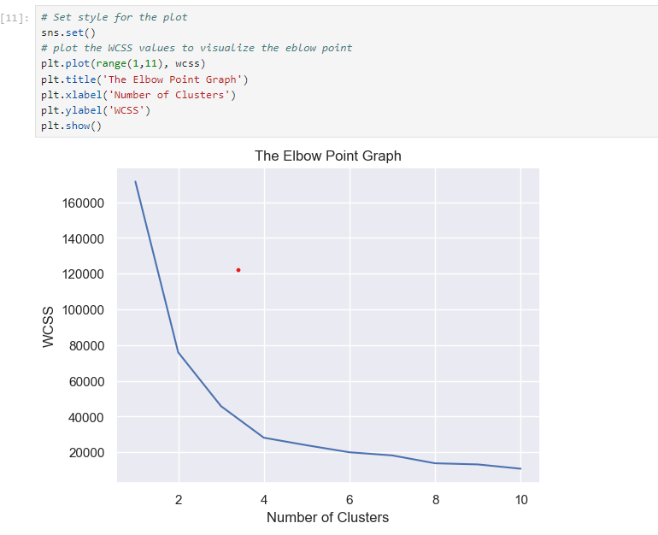

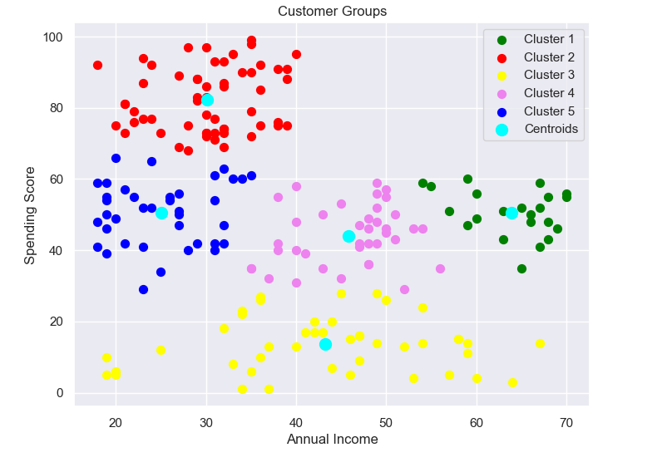

CHAPTER-6

CONCLUSION:

Customer segmentation using the K-means clustering algorithm provides a powerful method for understanding diverse customer behaviours and characteristics. By systematically collecting and preprocessing data, selecting relevant features, and using techniques like the Elbow Method and Silhouette Score to determine the optimal number of clusters, businesses can create meaningful customer segments. Implementing K-means with advanced techniques such as K-means++ for initialization and PCA for dimensionality reduction ensures robust clustering. Evaluating the quality of these clusters and interpreting them based on dominant features allows businesses to tailor marketing strategies and personalize customer experiences effectively. Continuous monitoring and updating of clusters ensure that the segmentation remains relevant as customer behaviours evolve. This approach ultimately leads to more targeted marketing, improved customer satisfaction, and better business outcomes.

CHAPTER-7

FUTURESCOPE:

Customer segmentation is a critical component of modern marketing and business strategy.

The future scope for customer segmentation includes:

1. AI and ML: Advanced algorithms for deeper insights and predictive analytics.

2. Real-Time Segmentation: Immediate personalization based on live interactions.

3. Hyper-Personalization: Tailoring marketing efforts to individual preferences.

4. Omnichannel Integration: Unified customer data across all channels for consistent experiences.

5. Behavioral Segmentation: Analyzing customer behaviour for more accurate targeting.

6. Privacy and Ethics: Balancing data use with privacy concerns and regulations.

These trends will enable businesses to understand and engage their customers more effectively.